Docker for windows 10 Installation and Commands

Installation:

Step 1: We need to install the docker from <https://hub.docker.com/editions/community/docker-ce-desktop-windows>

Step 2: We need to run the downloaded file from the docker hub and the windows will restart a couple of time to complete the installation of the docker.

Step 3: We should should check the hyper virtualization status from the task menu and to enable it we should go in the bios menu in advanced security settings and enable the same.

Step 4: We should create a id in the docker hub website and login in the docker desktop application to run the docker.

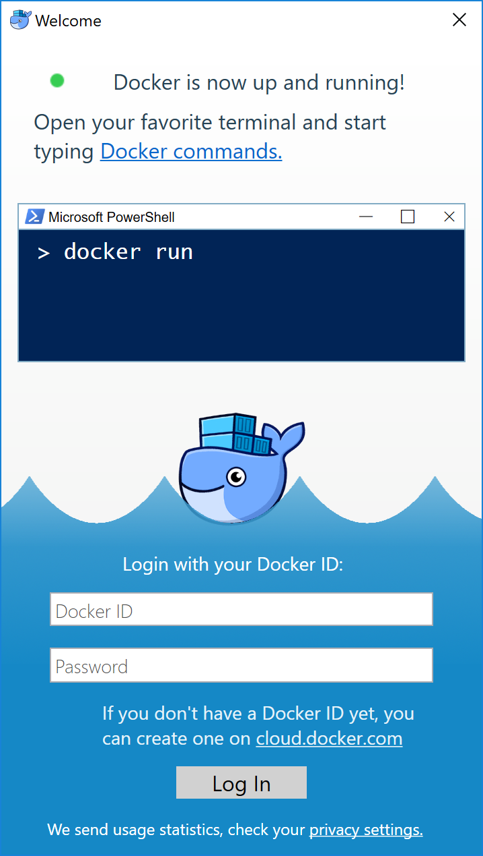

The whale in the status bar stays steady. Docker is up-and-running, and could be accessible from any terminal window.

**TESTING THE COMMANDS:**

**Checking the docker version**:

Run docker - -version command to ensure that you have a supported version of the docker

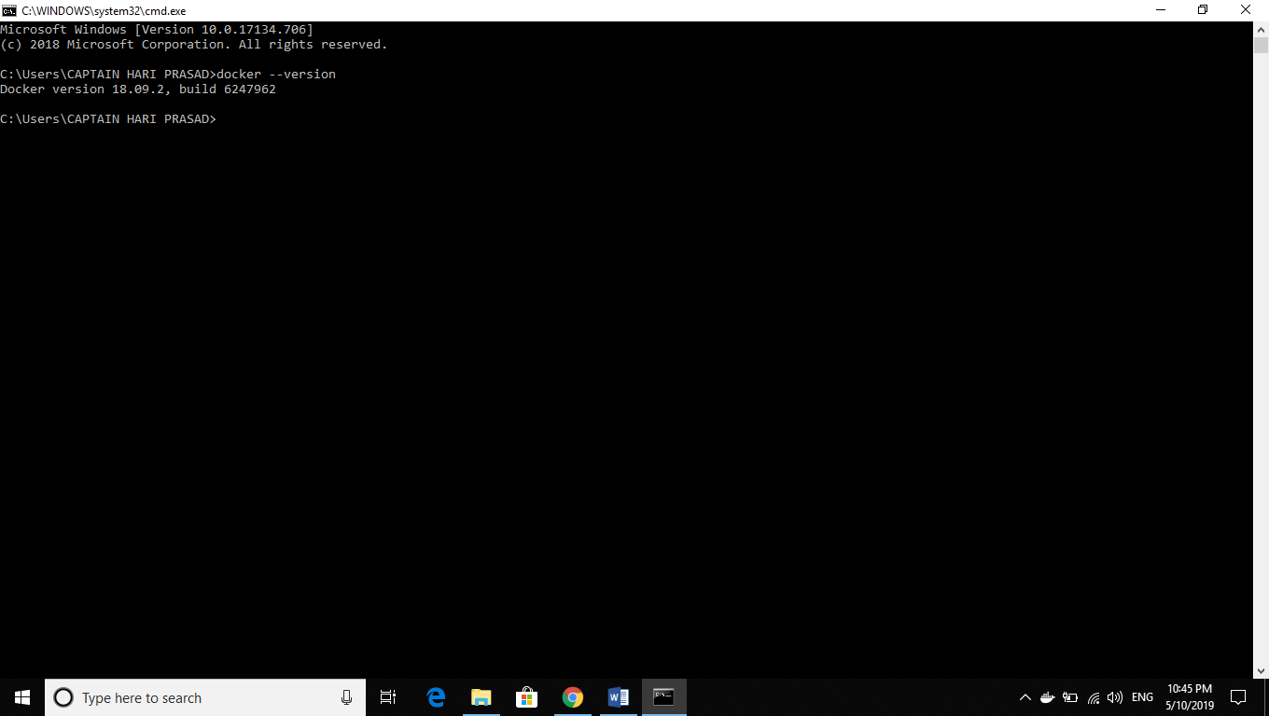

**Checking the docker info**:

Run docker info to provide more details of the docker installation.

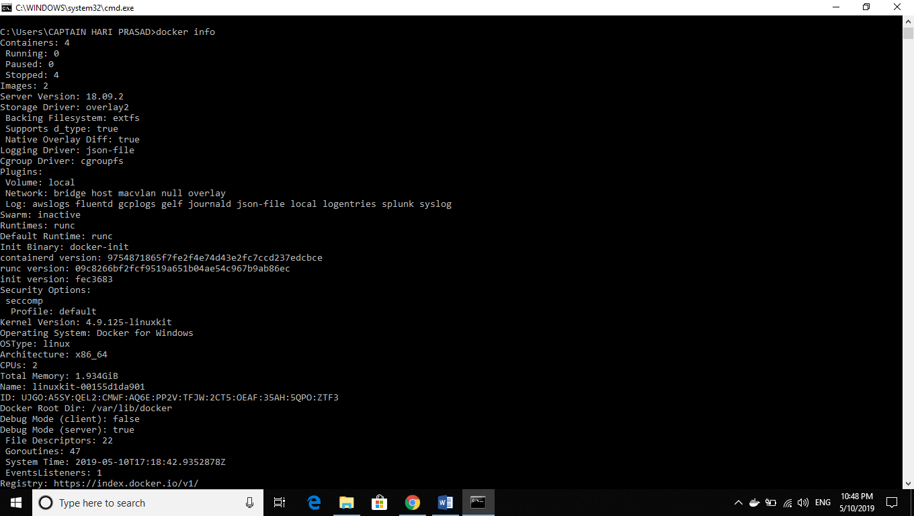

**Testing the docker installation:**

1. Test the docker installation by running a simple docker image , hello world

Cmd: Docker run hello-world

Output:

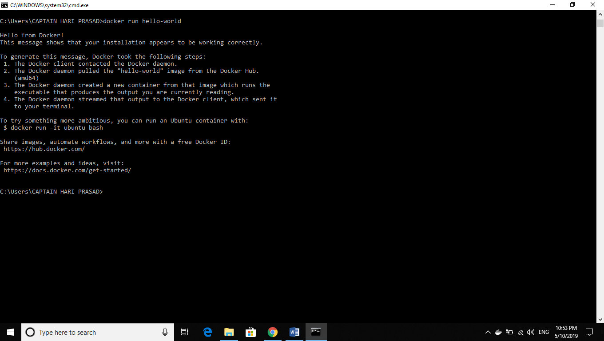

1. List the hello-world image that was downloaded to the machine

Cmd: docker image ls

Output:



1. List the hello world container

Cmd: docker container ls –all

Output:

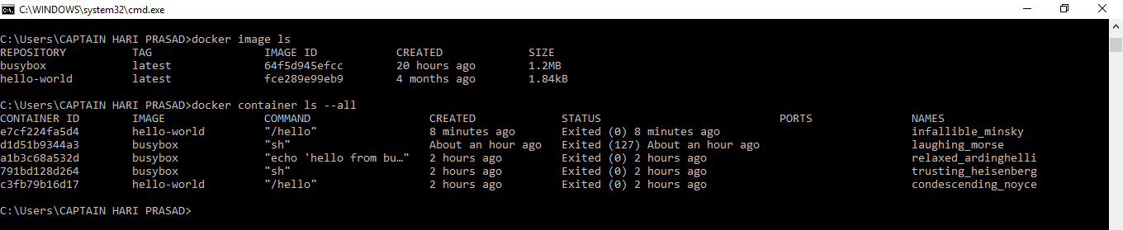

References:

<https://docs.docker.com/get-started/part2/>

<https://docker-curriculum.com/>

<https://docs.docker.com/get-started/>